Adding access table to Reports

1. In your view join to ACCES on CODACS_0 (EMPLOID) = CODACC_0 (ACCES) and CONSUL_0 (ACCES) = 2
2. In your report create a parameter for the user id called (YX3USR)

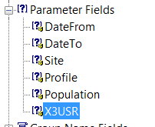

1. Edit the parameter to have the following highlighted values/settings:

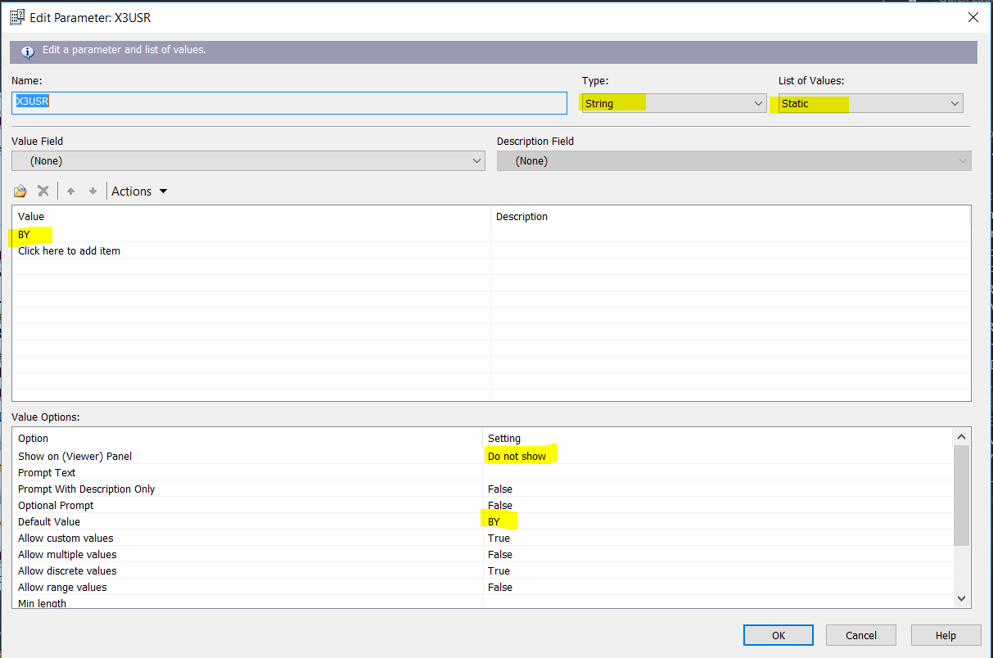

1. Add a filter to the report to link to the parameter:
2. Go to Report -> Select Expert -> Record
3. Select the Formula Editor

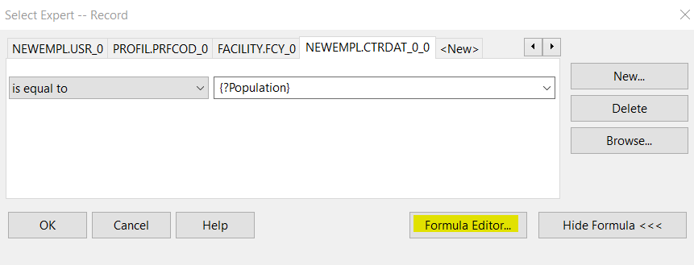

1. In the Formula Editor add the following line:

{Your View.USR_0} = {?X3USR}

1. Save and Close